**Indian Coin Change**

**Problem**

You are given an array of denominations and a value X. You need to find the minimum number of coins to make value X.

{Note: We have an infinite supply of each coin.}

**Example**

Consider the array of denominations

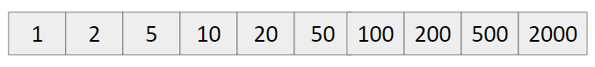

X = 388

So we can disintegrate it as

388 = 200 + 100 + 50 + 20 + 10 + 5 + 2 + 1

**Approach**

1. Start from the largest value, till we can include it, take it.
2. Else move on the smaller value.

**Code**

#include<bits/stdc++.h>

using namespace std;

#define int long long

signed main() {

int n; cin >> n;

vector<int> a(n);

for(int i=0; i<n; i++) {

cin >> a[i];

}

int val; cin >> val;

sort(a.rbegin(), a.rend());

int ans = 0;

for(int i=0; i<n; i++) {

int currCoin = a[i];

ans += val/currCoin;

val %= currCoin;

if(!val)

break;

}

cout << ans << endl;

return 0;

}